Queries:
- Display the employee First name, last name, Salary and Department number in department 30 whose salary from 1000 to 2000 LE monthly
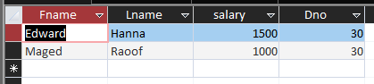
QUERY:
SELECT
Fname, Lname, salary, Dno
FROM
Employee
WHERE
Dno = 30
AND
Salary BETWEEN 1000 AND 2000
;

- Display all the projects names, locations and the department number which is managed by it.
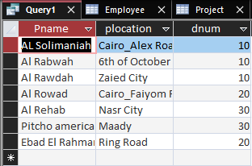
QUERY:
SELECT
Pname, plocation, dnum
FROM
project
;

- If you know that the company policy is to pay an annual commission for each employee which specific percent equals 10% of his/her annual salary .
Display each employee full name and his annual commission in an ANNUAL COMM column (alias).
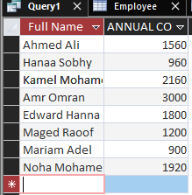
QUERY:
SELECT
Fname + ' ' + lname as [Full Name], Salary*0.1*12 as [ANNUAL COMM]
FROM
employee
;

- Display the employees Id, fname who earns more than 10000 LE annually.
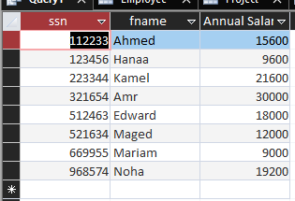
QUERY:
SELECT
ssn, fname, Salary*12 as [Annual Salary]
FROM
employee
;

- Display the names and salaries of the female employees
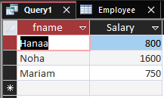

QUERY:
SELECT
fname, Salary
FROM
employee
WHERE
sex = 'F'
;

- Display each department id, name which managed by a manager with id equals 968574.
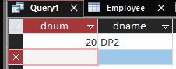

QUERY:
SELECT
dnum, dname
FROM
departments
WHERE
mgrssn = 968574
;

- Display the project id, name and location of the projects which controlled with department 10 or 20, and location of the projects in Cairo or Alex city
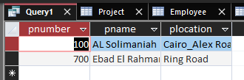
QUERY:
SELECT
pnumber, pname, plocation

FROM
project

WHERE
dnum IN (10, 20)

AND
city IN ('Alex','Cairo');

- Display the Projects name, locations of the projects with a name starts with "a" letter.
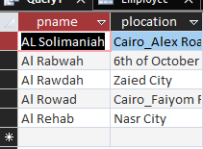
QUERY:
SELECT
pname, plocation
FROM
project
WHERE
pname like 'a*'
;

- Display the department number and maximum of salary in each department
Display only departments that has employees, and has number of employees greater to or equal 2 employees
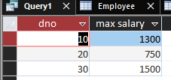
SELECT
dno, MAX(salary) as [max salary]
FROM
employee
GROUP BY
dno
HAVING
COUNT(dno) >=2;

Data Manipulating Language:
- Insert new employee with your personal data, you will be in department number 30, your SSN = 666666 , salary = 1000 & Superssn = 112233.

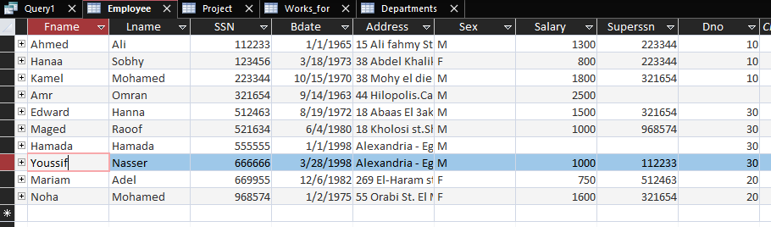
QUERY:
INSERT INTO
employee
VALUES
('Youssif', 'Nasser', 666666, 3/28/1998, 'Alexandria - Eg', 'M', 1000, 112233, 30);

- Insert another employee with personal data your friend as new employee in department number 30 , SSN = 555555, but don’t enter any value for salary or supervisor number of him.
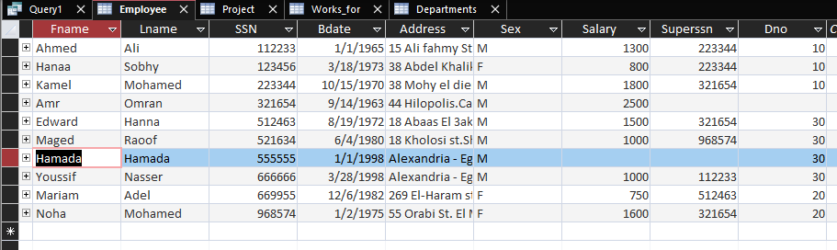
QUERY:
INSERT INTO
employee
(fname, lname, ssn, bdate, address, sex, dno)
VALUES
('Hamada', 'Hamada', 555555, 1/1/1998, 'Alexandria - Eg', 'M', 30);

- In the department table insert new department called "DEPT IT", with id 100, MgrSSN = 112233 as a manager for this department. The start date for this manager is '1/11/2006'

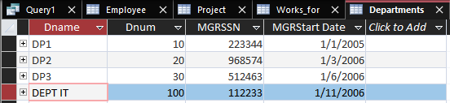
QUERY:
INSERT INTO
departments
VALUES
('DEPT IT', 100, 112233, '1/11/2006');

- Do what is required if you know that : Mrs.Noha Mohamed moved to be the manager of the new department (id = 100), and they give her position to your friend
Steps:
  - Your friend will be the manager of Dept 20 (her previous department)
  - Update Noha Mohamed to be the manager of department 100
  - Update your friend data, add yourself as a supervisor for him (supervised by you)
Updating employee dep  QUERY 1:  UPDATE  employee  SET dno = 100  WHERE  ssn = 968574; | 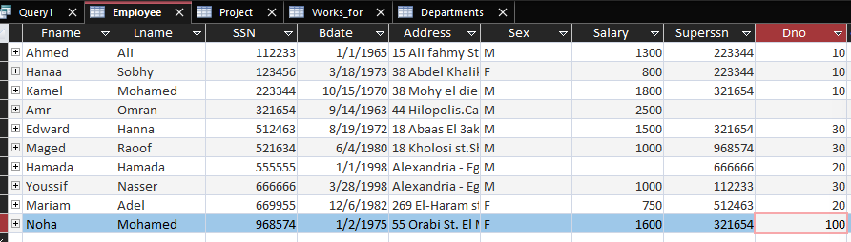
Updating dep MGRSSN  QUERY 2:  UPDATE  departments  SET  mgrssn = 555555  where  dnum = 20;  QUERY 3:  UPDATE  departments  SET  mgrssn = 968574  WHERE  dnum = 100; | 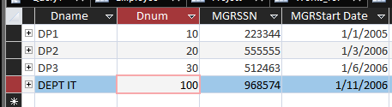
Updating employee superssn:  QUERY 4:  UPDATE employee  SET  superssn = 666666  WHERE  ssn = 555555; | 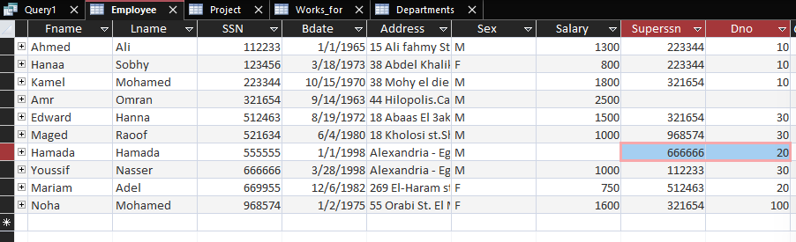

- Unfortunately the company ended the contract with Mr.Kamel Mohamed so try to delete his data from your database, in case you need, you can be temporary in his position.
Upgrade your salary by 20 percent of its last value.

Update dep mgrssn  QUERY 1:  UPDATE  departments  SET  mgrssn = 666666  WHERE  dnum = 10;  QUERY 2:  UPDATE employee  SET superssn = 666666  where superssn = 223344;  Updating salary  QUERY 3:  UPDATE employee  SET salary = salary + salary*0.2  WHERE  Ssn = 666666; | 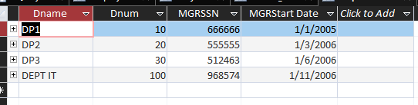  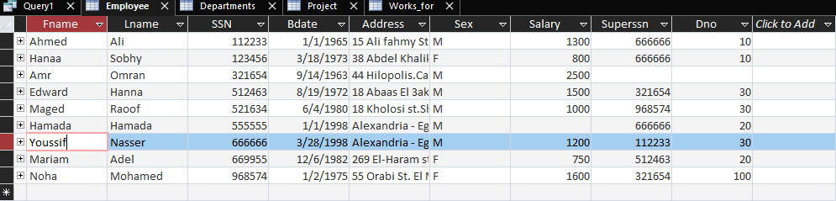
Removing emp:  QUERY 3:  DELETE FROM  works_for  where essn = 223344;  Query 4:  DELETE FROM  employee  where ssn = 223344; | 